AGREEMENT FOR ASSIGNMENT OF INVENTIONS, COVENANT
AGAINST DISCLOSURE AND AGREEMENT NOT TO COMPETE

I, _____Vidhyamalathi M_______ currently residing at ____Coimbatore_____ ________________________________ with permanent residence at, ______Coimbatore____, this ______18_____ day of ____January____ (Month), __2024__ (year), having been employed/retained by Hexaware Technologies Ltd., (hereinafter referred to as Hexaware) having its registered office at 152, Millennium Business Park, TTC Industrial Area, Sector-3, A-Block, Mahape, Navi Mumbai 400 701, from __18 January 2024___ (date of joining/retaining) agree to the following term

Property rights: During and after my employment/engagement with Hexaware, I will not disclose or use any knowledge or information of an unpublished, confidential, proprietary, or trade secrete nature generated or otherwise acquired by me from Hexaware or its customers. I agree that all concepts, designs, inventions, or improvements which I may conceive, make, invent, or suggest during my employment by Hexaware Tech Ltd. relating generally to any matter of thing, including computer programs, systems, designs, manuals, documentation, products, processes, or methods which may be connected in any way with Hexaware Tech Ltd. work or with work or tests carried on by Hexaware Tech Ltd., shall become the absolute property of Hexaware Tech Ltd.

Obligations: During and after my employment with Hexaware Tech Ltd, I will keep all such knowledge and information confidential.

*Disclosure: I agree to disclose promptly to my immediate supervisor all such concepts, designs, inventions, improvements, and any developments, I have made during my tenure with Hexaware Tech Ltd.

Return of Documents: At the conclusion of my employment/engagement with Hexaware, or on demand at any time during my employment / engagement, I will immediately return to Hexaware any drawings, writing, prints, documents, computer media, samples, prototypes, parts, or anything else containing, embodying, or disclosing any of Hexaware’s or its customer’s unpublished, confidential, proprietary, or trade secret information that are in my possession or subjects to my control. I understand that all such materials, whether generated by me or by others, shall at all times remain property of Hexaware Tech Ltd. or its customers.

*Compliance Not Contingent Upon Additional Consideration: I have not been promised, and I shall not claim, any additional or special payment or compensation for such assignments and for compliance with the other covenants and agreements herein contained.

*Prior Inventions: If, prior to the date of execution of this Agreement, I have made or conceived any unpatented inventions, improvements, concepts, designs, or developments, whether patentable or unpatentable, which I desire to have excluded from this Agreement, I have attached to this Agreement a complete list and brief description thereof

*Covenant Against Disclosure: In addition to all other obligations with respect to the observance of the local government security regulations, I understand that it may be desirable or necessary for the Hexaware Tech Ltd. or any of its suppliers, licensors, or customers to disclose to me information relating to the technology, systems methods of operations, products, and business data of Hexaware Tech Ltd. or its suppliers, licensors, or customers and, I therefore agree as follows:

(a) To accept and retain such data and information in complete confidence and, at all times during or after the termination of my employment, not to disclose or reveal such data or information to others and refrain from using such data for purposes other than those purposes authorised in writing by the Hexaware Tech Ltd..

(b)Not to directly or indirectly publish, communicate, divulge, or describe to any unauthorized person nor use, claim, patent, or copyright any such data or information during the term of my employment or at any time subsequent thereto without the prior written consent of the Hexaware Tech Ltd.

(c) To keep the contractual relationship of the Hexaware Tech Ltd. with its Hexaware Tech Ltd. suppliers, licensors, or customers confidential. I further agree not to disclose any supplier, licensor, or customer relationships to any third party.

*Agreement Not to Compete: Since I am employed in a position in which I may have intimate and complete knowledge of the operations, products, services, systems, methods and trade secrets of Hexaware Tech Ltd, many of which are unique, patented, and specially developed by Hexaware Tech Ltd and allow Hexaware Tech Ltd to effectively compete in its business, I hereby agree that during my term of employment with Hexaware Tech Ltd, I will not directly or indirectly, either as principal, agent, employee, representative, consultant, or in any other capacity, contact, communicate with, or have any other business dealings with any customer of Hexaware Tech Ltd, as defined in this section below, with whom I have had any contact, communications, or business dealings with during my terms of employment with Hexaware Tech Ltd, except as specifically authorized by Hexaware Tech Ltd.

I also agree that for a period of two years after my termination of employment with Hexaware Tech Ltd, I will not contact, communicate, or have any business dealings with, either directly or indirectly, any customer of Hexaware Tech Ltd. “Customer” includes those who are customers of Hexaware Tech Ltd. on the date of termination of this contract as well as those who were customers of Hexaware Tech Ltd. at any time two years prior to the termination of this contract. For avoidance of doubts, I understand that my obligation of "not to compete" as mentioned in this agreement will apply to all customers of Hexaware Tech Ltd or clients of customers on whose projects I am deputed or assigned whilst being in the employment of Hexaware Tech Ltd.

I further agree that during my term of employment with Hexaware Tech Ltd, I shall devote my skills and best efforts to the service of Hexaware Tech Ltd. and not perform any other activities for any competitor of Hexaware Tech Ltd.

Reasonable Scope: I understand that unauthorized disclosure or use of Hexaware’s or its customer’s, unpublished confidential, proprietary, or trade secret information is likely to Cause irreparable harm to Hexaware or its customers. I agree that Hexaware or its customers shall be entitled to, individually or jointly, an injunction restraining such unauthorized use of disclosure without (i) proof or irreparable harm or (ii) posting an injunction bond.

* In the event that any provision of this paragraph is deemed to be overly broad and unenforceable, the parties hereto stipulate and agree that any court of competent jurisdiction shall have the right to so limit, amend, or construe said provision so that the same shall be enforceable and hereby request the court to so act.

*Severability: Each paragraph and provision of this Agreement is severable from the contract and if one provision or part thereof is declared invalid, the remaining provisions shall nevertheless remain in full force and effect.

*Entire Agreement: This Agreement shall inure to the benefit of and be binding upon my heirs, executors, administrators, and assigns and the successors and assigns of Hexaware Tech Ltd.

The Failure of Hexaware to exercise its rights under or insist upon strict performance of the provision of the Agreement shall not operate as a waiver thereof or preclude Hexaware from exercising its rights.

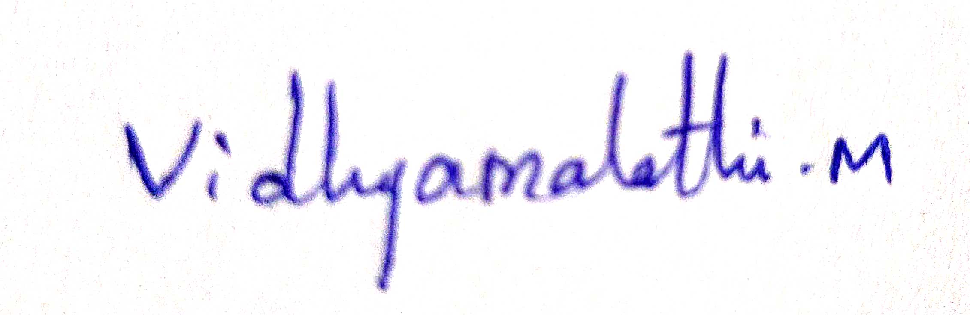
Signature:

Print Name: Vidhyamalathi M
Date: 17-12-2023
Place: Coimbatore
Witness (1): Witness (2):
Signature: Signature:
Name: Name:
Address: Address:

Date: Date:

Confidential: Page 1

COMMERCIAL SOFTWARE PROTECTION AGREEMENT

I agree that, in consideration for using Hexaware Tech Ltd. computer hardware and all software, including commercial software as part of my employment, I recognize and will abide by the following conditions:

Hexaware Tech Ltd. licenses the use of its commercial software from a variety of outside companies. Hexaware Tech Ltd. does not own this software or its related documentation and unless authorized by the software developer, does not have the right to reproduce it.

With regard to use on local area networks or on multiple machines, Hexaware Tech Ltd. employees and consultants shall use the software only in accordance with the license agreement. Information on the license agreement for each piece of software can be obtained from Hexaware Tech Ltd. Manager of Information Systems Division.

Hexaware Tech Ltd employees and consultants learning of any misuse of software or related documentation within the company shall notify their supervisor or the Manager of the Information Systems Division.

Hexaware Tech Ltd. employees and consultants who make, acquire, or knowingly use unauthorized copies of computer software will be disciplined as appropriate under the circumstances.

According to the Copyright Law, illegal reproduction of software can be subject to civil damage, and criminal penalties including fines and imprisonment.

Hexaware Tech Ltd. does not offer protection to any employee from prosecution by the owner, developer, maker, or distributor of the original commercial software.

Employee’s Name: Vidhyamalathi M
Signature:

Date: 17-12-2023

PLEASE READ, SIGN, AND RETURN TO THE PERSONNEL DEPARTMENT AS SOON AS POSSIBLE

